STEP 1: ENTER THE INPUT:”ENTER THE STRING”
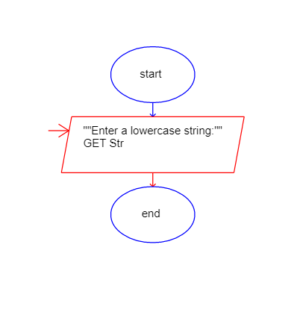
STEP 2:GET THE ASSIGNMENT SYMBOL ADD THE SET,VALUE VALUES IT
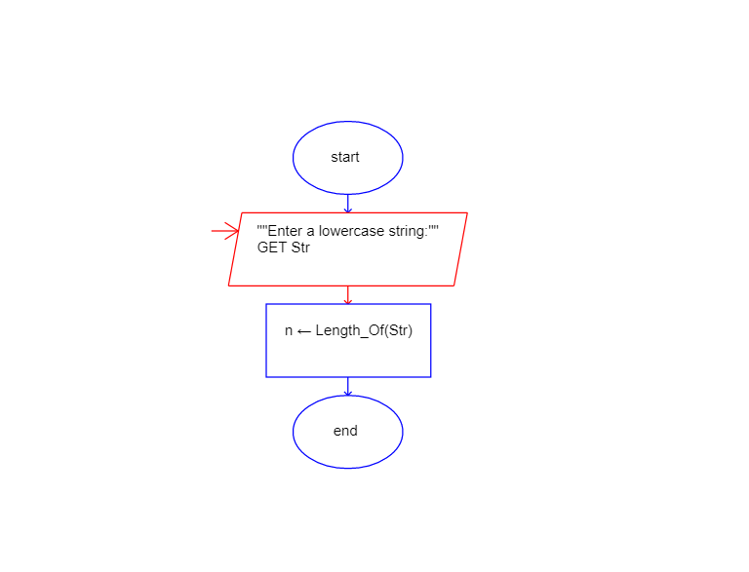
STEP 3: ADD THE TWO ASSGINMENT SYSMBOL SET,TO VALUES IN IT
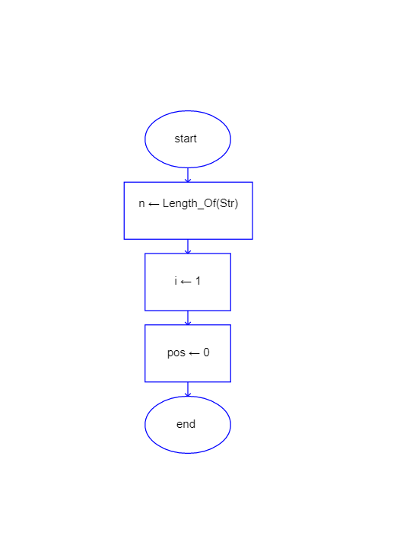

STEP 4:ENTER THE SYMBOL LOOP BELOW THE ASSGINMENT OPERATOR
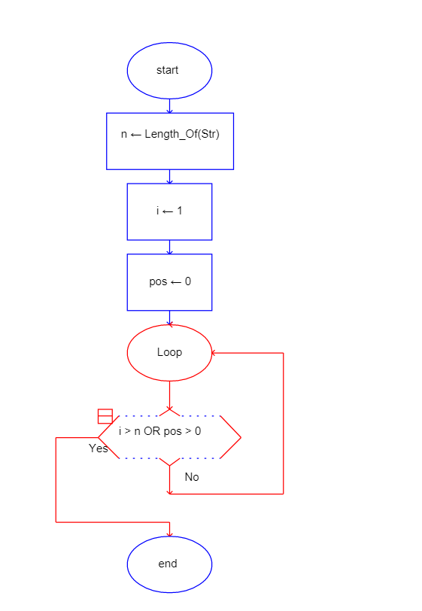

STEP 5: ADD THE TWO-ASSIGNMENT SYMBOL INSIDE IT


